COHORT ANALYSIS

REPORT by: Aditya Sharma

**Overall User Retention: -**

* As observed, the data seems skewed towards March 2021 with only one user. The problem is may be because of the limitation of the data points.
* Focusing on the other cohorts, we see a pattern of higher first-month retention (Month0Users) followed by a decline in subsequent months (Month1Users and Month2Users).

This highlights the need to **improve engagement and retention beyond the initial acquisition phase.**

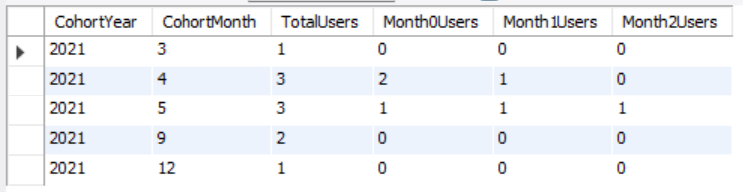**Cohort-Specific Trends:**

* April 2021: The consistent drop in retention across all months strongly suggests investigation into potential onboarding/customer satisfaction or user experience issues specific to this cohort.
* May 2021:  This uneven retention rate suggests that maybe product is catering to the needs of limited range of customers which we can see did stick and keep purchasing/using the services, while the services may have failed in fulfilling the needs to a satisfactory level of the other customers.
* September -December: Sudden decline in retention rate suggests some actions needs to be taken to increase product/service quality and retention rate.

**Personal Insights and Recommendations:**

* **Prioritize improving retention beyond the first month**: Implement strategies to engage users after acquisition. It's about creating a User Experience that makes them want to come back.
* **Conduct deeper analysis of specific cohorts**: Take a closer look at different user groups. What are they into? What makes them stay, and what might be making some of them slip away? Understanding these details can help in fine-tuning the game plan.
* **A/B test onboarding and Trying New Strategies**: We can test different ways to welcome and engage users. A bit of trial and error can lead us to the perfect recipe for user happiness.
* **Gather user feedback**: **User feedback is gold**. Understand user **pain points** and preferences through surveys etc.